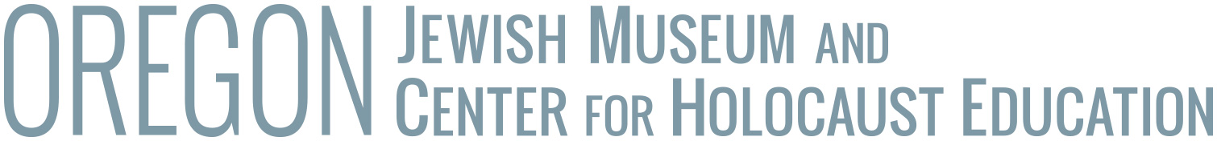

Reproduction and Usage Fee Schedules

Image Production Fees
•All prices below are for reproduction only.
•Images to be used in publication or any public purpose are subject to Usage fees.
•All images remain the property of the Museum

Prints
• 5x7prints $5.00
• 8x10 prints $10.00
• 11x14 prints $15.00
• 16x20 prints $45.00
• 20x24 prints $60.00

Digital Scans
• .jpg or .tif $10.00

Laser prints from existing scans
• up to 8x10 $5.00

Photocopies
• Photocopies per page $.20

Media Usage Rights
The museum will grant use of media reproductions for one-time, one-use, non-exclusive, single language, exhibition or publication.

Use | For Profit entities | Non-profit entities
Editorial (books, periodicals, etc.) | $75.00 | $25.00
Video and Film Productions | $100.00 | $50.00
Exhibition | $150.00 | $25.00
Presentation | $25.00 | $5.00
Advertising and other non-editorial use | $250.00 | $125.00
eBook | $250.00 | $125.00
Web use or use in CD-ROM | $500.00 | $250.00

Payment
Advance payment is required for all orders unless special arrangements have been made prior to placing the order.

Conditions

1 To use the media reproduction only once and only for the purpose listed by requester as "Statement of Intended Use." Any subsequent editions constitute reuse and must be applied for in writing.

2 To credit properly. The following is the basic credit line: “Oregon Jewish Museum and Center for Holocaust Education”. We ask that you follow these guidelines:

* For published materials, the credit line should appear on the same or facing page as the illustration. Each individual image used must be credited separately.
* For films, filmstrips, and video presentations, include the credit within the "Sources for Illustrations" or "Credits" section of the production.
* For exhibitions, credit should appear in the exhibition area, preferably directly below or adjacent to the original copy.
* For Web use, credit should appear either adjacent to the image or in a "Sources of Illustrations" section and must include a "link" or the Uniform Resource Locator for the OJMCHE Web page.

3 To give the Museum one complimentary copy of any published work, including CD-ROM products, in which the media reproduction appears.

4 To indicate in the accompanying caption or label any and all changes or alterations made to the original copy, including cropping, tinting, or detailing.

5 To not permit others to reproduce the media reproduction or any facsimile of it.

6 In authorizing the reproduction of works within its collections, the Oregon Jewish Museum does not surrender its right to publish or grant permission to others to do so.

7 The Oregon Jewish Museum and Center for Holocaust Education reserves the right to limit the number of media provided; to restrict the use of reproduction of rare or valuable materials; and to charge different fees than the ones published herein.

